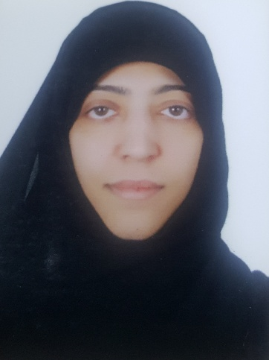

***Name : Abdat Ali Hasan Ali Hasan***

***Nationality*** : Bahraini

***Date Of Birth*** : 10 Feb 1981

***Mobile*** : 37226694

***E-mail*** : [abdatalarnoot@gmail.com](mailto:abdatalarnoot@gmail.com)

***Address*** : House : 802 , Road : 1018

Al hamalah : 1010

Bahrain

***Personal Information***

* ***Marital status :*** Married
* ***Nationality :*** Bahraini
* ***Date Of Birth*** : 10Feb 1981

***Objective***

To be a successful Woman That Makes An Effect & Change In My Country In Different Life Fields .

***Education***

1. 1987 _ 1990 Isa Town Primary School
2. 1990 _ 1993 Safia Bent A.Almutalib Primay School
3. 1993 _ 1996 Hamad TownIntermeiate School
4. 1996 _ 2000 Hamas TownSecondary School

***Other Skills***

* Ability To Develop Plans & Strategies ( For Projects / Activities Of The Cmmunity ) .
* Race & good Disposition .
* Ability To Take The Responsibility , Leadership & Management .

The Ability To Organize Events , Lactures & Activities .

***Skills***

* **Interpersonal Skills :**

1. Able To Handle Tough Sitution .
2. Excellent Communication Skills To Build Relatioships With Customers Face To face .
3. Effective Time Management & Be Able To Prioritize .

* ***Computer Skills***  ***Ms Office Applications***

1. Use Cashier Program .
2. Excel , Word , PowerPoint .
3. Printing Proficiency In Arabic & English .
4. Proficiency In The Use Of The Internet .

***Interest & Activates***

1. Writing .
2. Drawing .
3. Use Computer .
4. Read Magazine .
5. Swimming .
6. Travelling .

***Languages***

* Arabic Native Speaker .
* English second Language .

***Current Job***

* ( **2009 _ 2015** ) Working As A Cashier At ***Home Electronic .***
* ( **14 Oct _28 Apr 2016 )** Working As Teller At **Exchange & Money Transfer Alyex .**
* **( 29 Apr 2016 _ 31 Dec 2018** ) Working As ACashier At **Home Electronic .**